# JS Advanced: Retake Exam - 10.12.19

Exam problems for the ["JavaScript Advanced" course @ SoftUni](https://softuni.bg/courses/js-advanced). Submit your solutions in the SoftUni Judge system at <https://judge.softuni.bg/Contests/Compete/Index/1850#0> .

# Problem 1. Christmas Gifts Delivery (DOM Manipulation)

### Use the given skeleton to solve this problem.

### Note: You have NO permission to change directly the given HTML *(index.html file)*.

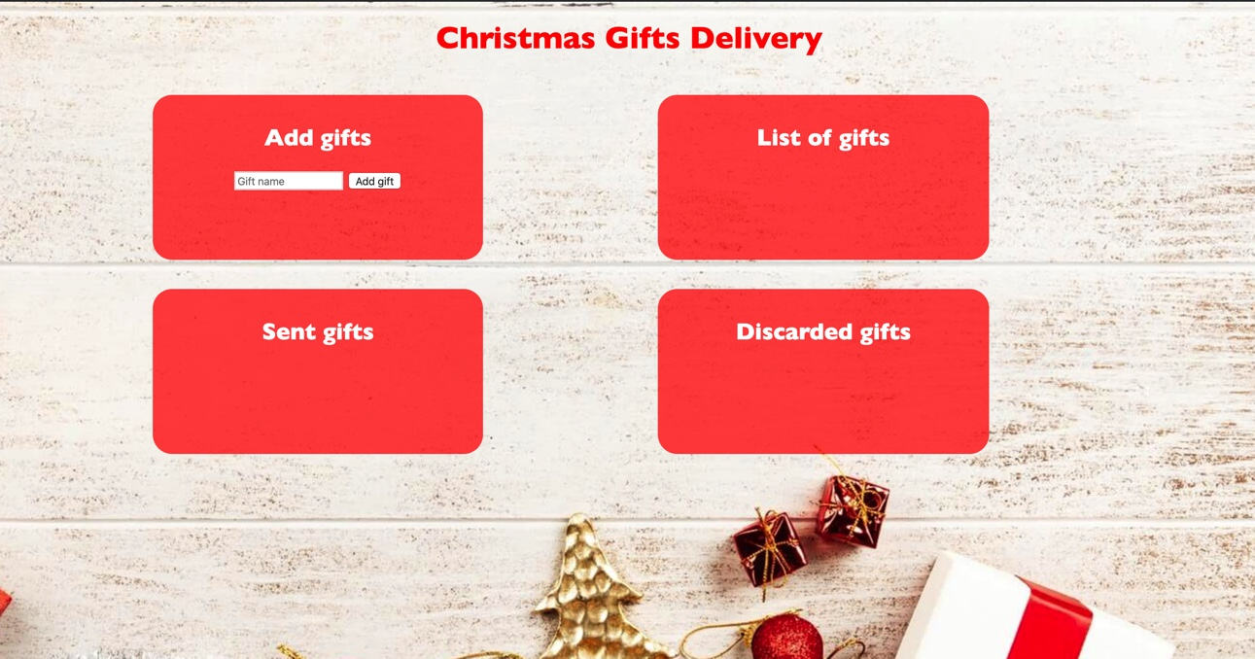

### Your Task

Write the missing JavaScript code to make the Christmas Gifs Delivery application work as expected.

You should be able to **add** new gifts to the list of gifts.

Each product has **name**. When you click the **[Add gift]** button, a new **list item** should be added to the **List of gifts**. To each list item you should put a **class “gift”**. Upon clicking the **[Add gift]** button you should **sort** the gifts **in alphabetical order** and you should **clear the input field.**

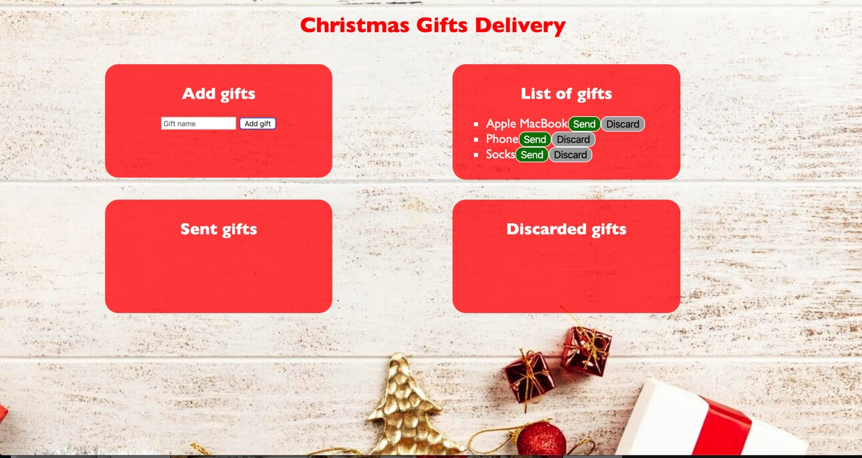

The new item should have the **following structure**:

* Append two buttons to each list item
  + Add class **“gift”** to each list item
  + **[Send]** button with id **“sendButton”**
  + 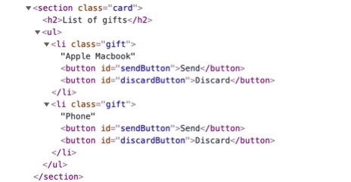**[Discard]** button with id **“discardButton”**

When you click the **[Send]** button you should move the list item to the **Sent gifts** section. **Important!** Do not move the entire list item, but only the name of the gift. You should leave the buttons behind.

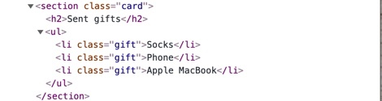

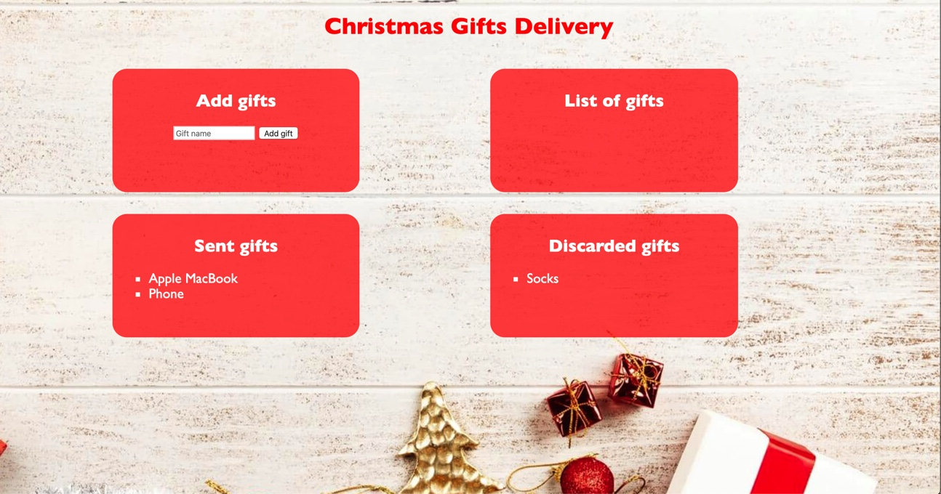When you click the **[Discard]** button you should move the list item to the **Discarded** gifts section. 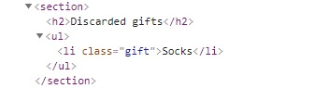**Important!** Do not move the entire list item, but only the name of the gift. You should leave the buttons behind.

*GOOD LUCK!😊*